
Affiliation No. 330010

FACILITIES 

SCHOOL BOARDING

- The Chhatravas over the years has come to symbolize the truest spirit of dedication to the task of maintaining a standard of living, a home away from home, and education which can be stated as being second to none. The Chhatravas has received the unstinted co-operation of its staff in this arduous task and the outcome has been a consistent excellence shown by the students not only in the academics but also in various fields of co-curricular activities.

THE HOSTEL

- The Chhatravas provides excellent hostel facilities for boarders both at Desh Ratan and Vitthal Vihar Complex. Our hostlers reside spread over a vast and open area in pollution free scenic surroundings in well furnished buildings. Lavish supply of fresh water from the pumping station of the school in maintained during all the hours of day and night. Heavy duty generating sets remain on stand by duty and are put in operation in case of electric supply failure. School curriculum is maintained as per programmes without any disruption.

THE MESS

- Tasty and nutritious food with varying daily menu is served to the satisfaction of the students. On Sundays and holidays, and also on festive occasions, food demanded specially by the students is served. Every effort is made to keep the borders contented and healthy. Food is prepared on gas under strict hygienic conditions by expert cooks. A very experienced mess manager supervises the cooking and serving aspects. The best fresh vegetables of the season are purchased.
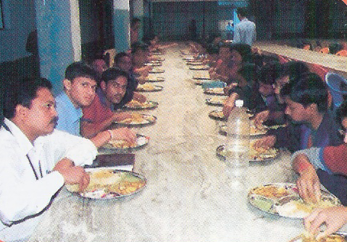
The Mess

MEDICAL FACILITIES

- A Doctor, with experienced and qualification has been appointed as the Medical Officer visits the hostel regularly, Medical check up of students is done and a record is maintained. Parents/Local guardians are informed if the doctor finds that a child needs special medical attention. Well equipped First-Aid box is available in the office round the clock and students sustaining minor injuries in course of training, sports or games are attended to immediately. One vehicle of the school remains on stand by duty to face any emergency.

LIBRARY

- The school has a good library, and Gyanis have regular library periods to inculcate the habit of reading in them as early as possible. Every year a large number of books are being added to update our collection of book. For boys of higher classes, we maintain a suitable set of books to add to their knowledge in different fields.
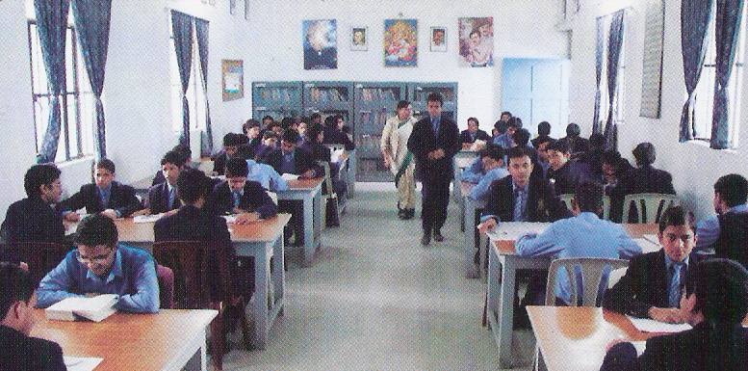
LIBRARY

COMPUTER LAB

- It also has a well developed computer laboratory for the pupils from Class V to Class-XII. Internet facility is also available to senior students.

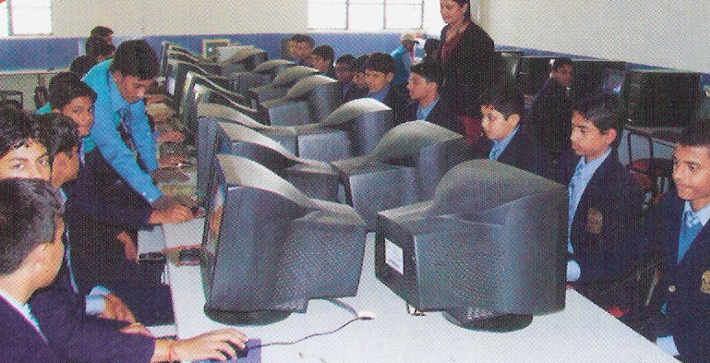
COMPUTER
LAB

LABORATORIES

- The school has got well equipped laboratories of Physics, Chemistry and Biology. A workshop for work-experience is provided. Qualified and experienced look after these laboratories and educate the students. Students are taken to the laboratories only after training them properly in the use of equipments/chemicals etc.

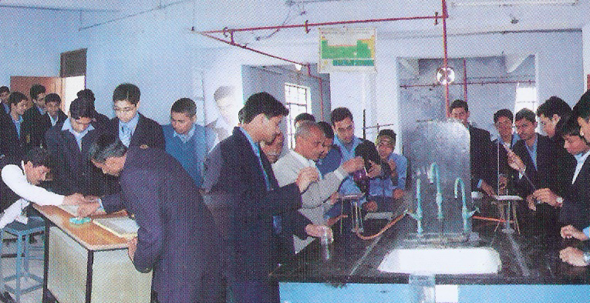
LABORATORIES

STATIONARY

- Book, notebooks, pen, pencils and materials needed for academic purposes are supplied to students from time to time on charges.

TAILORING

- A whole time master tailor is employed for making school uniform. He also repairs clothes of the students.

SCHOOL CANTEEN

- Gyan Niketan has a canteen to provide substantial nourishing and hygienically cooked food to day scholars as they have to remain in the school for a long period. Food items are supplied against coupons. Each coupon is valid for one week. The Menu varies from week to week. Boys can place the order in advance after seeing the menu and take the coupon.

ADDITIONAL FACILITIES

- Single bed for every boarder.
- Coaching by regular tutors for major subjects for all classes.
- Co-curricular activities.
- Moral education with special emphasis on Indian Culture and traditions.
- Secular atmosphere.
- Games and Sports.
- Sales Counter for books.
- Sales counter for uniform.
- A big playground.
- A good Library.
- A sophisticated computer lab in spacious room.

All Right Reserved © 2009 by Gyan Niketan, Patna

